Ideation Phase
Define the Problem Statements

Date | 31 January 2025
Team ID
Project Name | Cab Booking
Maximum Marks | 2 Marks
Customer Problem Statement :
Customers need a simple and quick way to book a cab online. Many people face delays and difficulty in finding available cabs. The booking process should be easy and secure. The Cab Booking System helps users book cabs quickly, view booking status, and save time with a better travel experience.
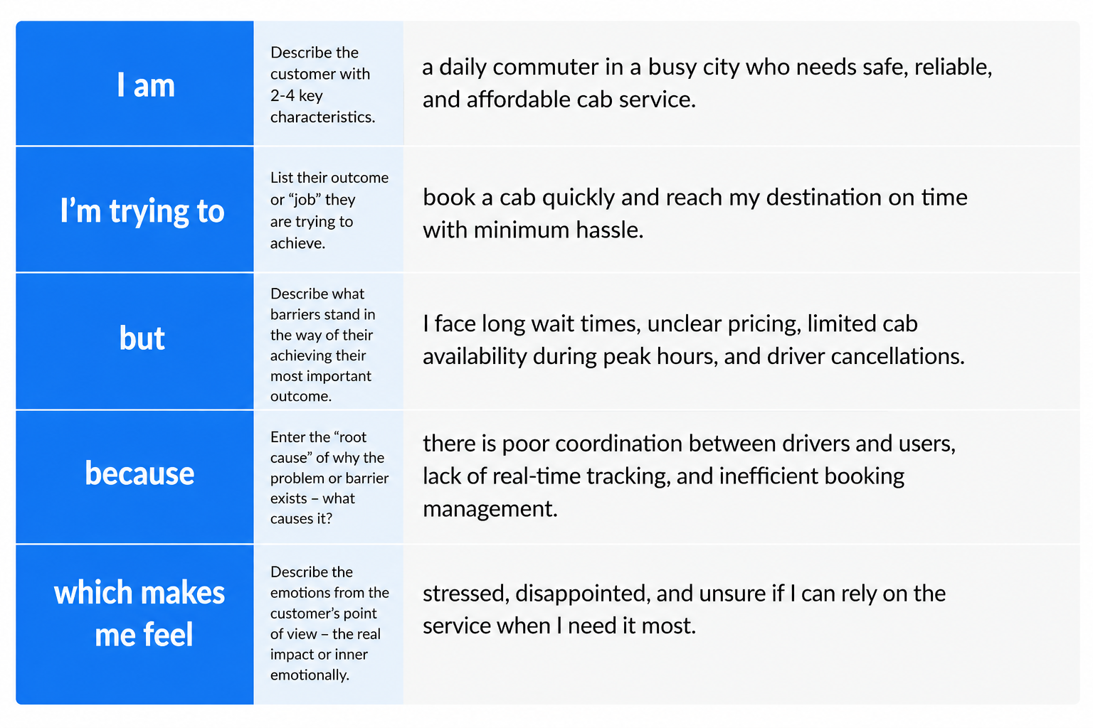

Problem Statement (PS) | I am (Customer) | I’m trying to | But | Because | Which makes me feel
PS-1 | A daily office commuter | Book a cab quickly to reach work on time | I face long waiting times and ride cancellations | There are limited drivers and high demand during peak hours | Frustrated and stressed
PS-2 | A traveler visiting a new city | Find a safe and affordable cab | I cannot easily find available cabs or know the fare in advance | There is limited real-time tracking and pricing transparency | Anxious and uncertain

